**Spreadsheet Gear HeavyBid Data Codes**

|  |  |
| --- | --- |
| **SG CODE** | **WHAT IT RETURNS** |
| ACTVCODE | Activity Code |
| ACTVDESC | Activity Description |
| ACTVQTY | Activity Quantity |
| ACTVUNIT | Activity Unit of Measure |
| BIDDESC | Biditem Description |
| BIDITEM | Biditem Number |
| BIDQTY | Biditem Quantity |
| BIDUNIT | Biditem Unit of Measure |
| CREWHRS | Crew Hours |
| EFFPERC | % Efficiency (Comprehensive Version Only) |
| PRODRATE | Production Rate Crew |
| TOQTY | Takeoff Quantity |
| USERDEF1 | User Defined Number 1 |
| USERDEF2 | User Defined Number 1 |
| USERDEF3 | User Defined Number 1 |
| USERDEF3 | User Defined Number 1 |

When one of these values are put into a cell in a spreadsheet being setup (system wide) with a “=” preceding each code it will look like below:

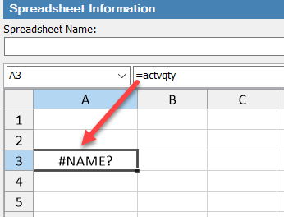

However once used in an Assembly or Calculation then the correct value will be inserted

By: Arthur Nix, HeavyBid Trainer

EWKS LLC

[anix@ewksol.com](mailto:anix@ewksol.com)

Feb 28, 2019

EWKS specializes in implementing and optimizing HCSS HeavyBid – Email me for more information